
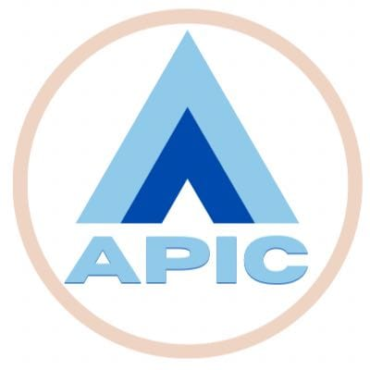
ASHOKA WOMEN’S ENGINEERING COLLEGE
(Autonomous)
Accredited by NBA (CSE, CIVIL, ECE, EEE), Accredited by NAAC - A⁺
Approved by AICTE & Affiliated to JNTUA, Ananthapuramu
(NH-44, Dupadu, Kurnool-518218)
22-06-2026
Circular-2
The following faculty members are requested to give presentations on the teaching methods mentioned below.
Venue: A-108
Teaching Method | Faculty Name | Date and Time
- Experiential Learning  - Case Based Learning  - Cooperative Learning  - Concept Mapping | Mr. A.V. Rama Krishna Reddy | 23-06-2026  10.00 to 12.00
- Problem based Learning  - Project Based Learning  - Journal Review process  - Inquiry Based Learning | Dr. S.Shoeb Peer | 23-06-2026  10.00 to 12.00
- Simulation Based Learning  - Jigasaw  - Collaborative Learning | Mrs. A.Haripriya | 23-06-2026  10.00 to 12.00
- Mind Mapping  - Analogy-Based Learning  - Blended Learning | Mrs. K .Swetha | 23-06-2026  10.00 to 12.00
- Time Line Mapping  - Gamfication (Kahoot)  - Service Learning | Mrs. N.Vasavi | 23-06-2026  10.00 to 12.00
- Just-in-Time Teaching (JiTT)  - Team-Based Learning | Mrs. D. Reshma | 24-06-2026  10.00 to 12.00
- Role Playing Activity  - Peer Learning  - Team-Based Learning | Mrs. K Adilakshmi | 24-06-2026  10.00 to 12.00
- Design thinking  - Discussion-Based Learning | Mrs. N.Sreelatha | 24-06-2026  10.00 to 12.00
- Scaffolded Learning  - Design Thinking  - Peer Learning | Mr.Khaleel Ahmed | 24-06-2026  10.00 to 12.00
- Flipped Class Room  - Think Pair Share  - Digital Story telling | Mr. S.MD. Elias Basha | 24-06-2026  10.00 to 12.00
Smart Board Training | The names of the faculty members are yet to be mentioned. | 25-06-2026  10.00 to 12.00

HOD-CSE(AI) CSE-HOD

